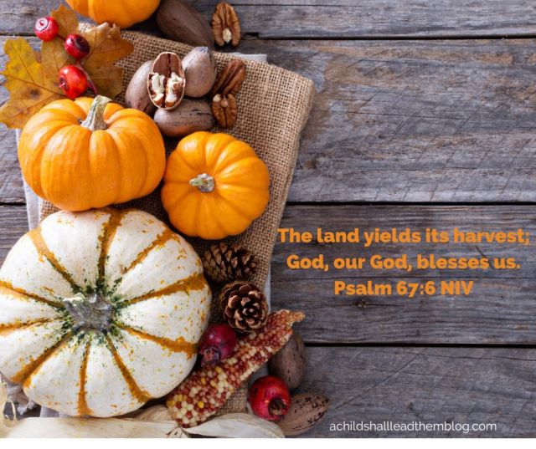
November 2025
Come Worship with Us!
Sundays 9:00 am
Wednesdays 6:30 pm

In this issue:
Calendar
Pastor Mackie’s Message
Upcoming Events
Celebrations
Birthdays and Anniversaries

Alleluia Lutheran Church
6725 Elmro Road
Greenleaf, WI 54126
920 532-3892
Alleluia.office@gmail.com
Alleluiawrightstown.org

Sun | Mon | Tue | Wed | Thu | Fri | Sat
 |  |  |  |  |  | 1
2  8:00 am Adult Bible Study  9:00 am Worship | 3 | 4  6:00 pm  Book Club | 5  9:00 am Card  Club  5:15 pm ACE/  Confirmation  6:30 pm Worship | 6 | 7 | 8  8:00 am Elders Mtg.  8:30 am Community Food Pantry
9  8:00 am Adult Bible Study  9:00 am Worship  Voters’ Meeting  Potluck | 10 | 11  6:00 pm FIRE  6:30 pm Focus on Health | 12  9:00 am Card  Club  5:15 pm ACE/  Confirmation  6:30 pm Worship | 13 |   14 | 15
16  8:00 am Adult Bible Study  9:00 am Worship  11:00 am Christmas Parade Prep | 17 | 18  6:00 pm Council meeting | 19  9:00 am Card  Club  5:15 pm ACE/ Confirmation Class  6:30 pm Worship | 20  6:00 pm MG Group | 21 | 22
23  8:00 am Adult Bible Study  9:00 am Worship  11:00 am Christmas Parade Prep | 24 | 25  6:00 pm Community Food Pantry | 26  9:00 am Card  Club  6:30 pm Thanksgiving Eve Worship  No ACE or confirmation class | 27 | 28   | 29
30

From Pastor Mackie

Fearless

This month of November starts with the commemoration of All Saints—those made holy by the
blood of the Lamb of God (Revelation 7:11-17). Last month’s newsletter article already mentioned that God’s Word does not make us holy by removing us from the world. Instead that Word shares Jesus’ holiness with us while we are in the world. That context helps us understand the first verses of the Psalm for All Saint’s Eve, better known as Reformation Day among Lutherans:

“God is our refuge and strength, an ever-present help in trouble. Therefore we
will not fear, though the earth give way and the mountains fall into the heart of the sea, though its waters roar and foam and the mountains quake with their surging.” (Psalm 46:1-3 NIV)

Conditions in the world suggest to many careful observers that conditions continue to deteriorate.
Shortly before he was betrayed, Jesus described what would happen during that deterioration (see Luke 21:5-36): false prophets, wars, revolutions, earthquakes, famines, pestilences, fearful events, signs in the heavens, persecutions and great distress among his people. These things continue to characterize our world. Furthermore, Jesus tells his disciples to watch for signs in the heavens in preparation for the shaking of heavenly bodies and the coming of the Son of Man in power and glory. Frightful times! People will be apprehensive about what is happening. Jesus encourages his disciples to set aside our common-place fears about such events:

“When these things begin to take place, stand up and lift up your heads,
because your redemption is drawing near.” (Luke 21:28 NIV)

In my heart, I struggle to be confident in less threatening situations than those described
in Psalm 46 and Luke 21. It helps to draw comfort from Jesus’ promise: “Heaven and earth
will pass away, but my words will never pass away. (Luke 21:33 NIV)

As we observe the Reformation of God’s Church, may we encourage one another with the
promise that despite fearful conditions, God is bringing our redemption near. In that trust
and confidence, may the Holy Spirit make us fearless in frightening conditions.


Childcare will be provided!
Join us in building Alleluia’s Christmas Parade Float!

Meet at LaFleur’s
(204 Haymeadow Court, Wrightstown)

November 16th 11:00 -2:00
November 23rd 11:00-1:00

We are looking for Walkers too!

Tuesday, December 2nd, Kaukauna Christmas Parade

Saturday, December 6th, Wrightstown Christmas Parade


Tuesday, November 11th at 6:30 pm
This month’s topic:
Preventing and managing diabetes and weight loss


The Annual Voters Meeting will be held on November 9th, following the 9:00 worship service. Nominations are being accepted for Vice President, Secretary, and Youth Director.
A potluck will follow the meeting.

Upcoming Events


Thanksgiving Eve Worship, November 26th, 6:30 pm
Christmas Eve Worship, December 24th, 4:00 pm
New Year’s Eve Worship, December 31st, 6:30 pm



Upcoming Events


No ACE or Confirmation Class November 26th!

Faith and Family Night with the Green Bay Blizzard!

March 15, 2026


We are excited to announce Alleluia will have a Christmas choir again this year! If you are interested, contact Joyce at 920-716-4864 .


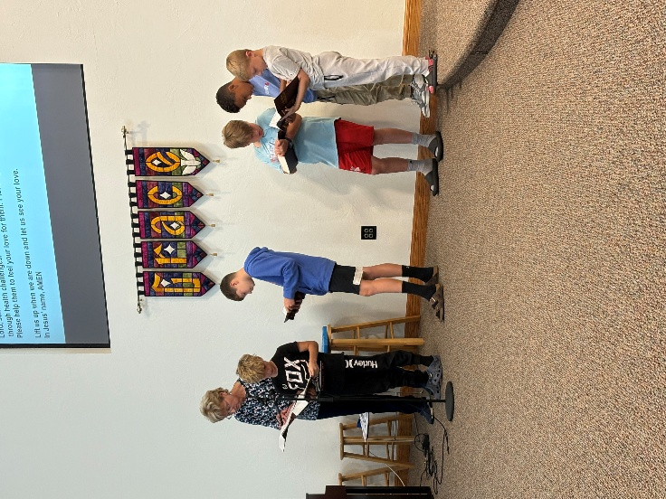
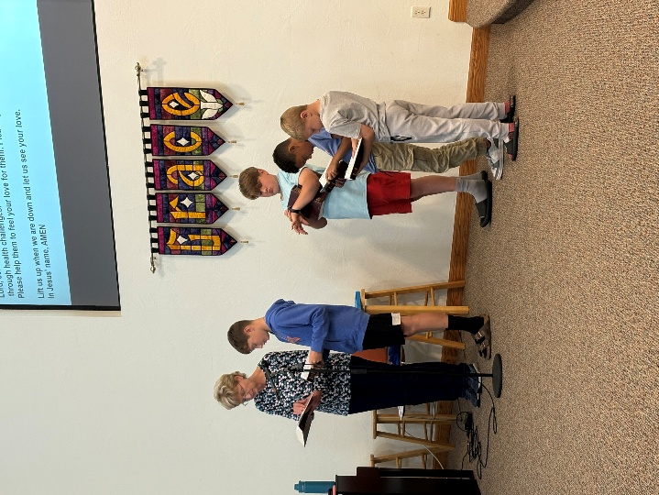
ACE FUN

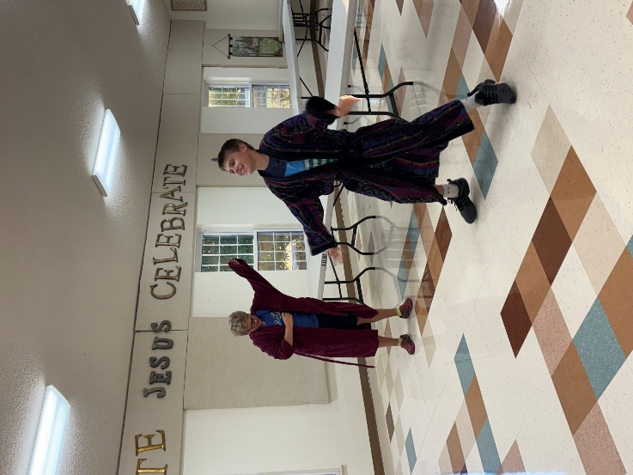
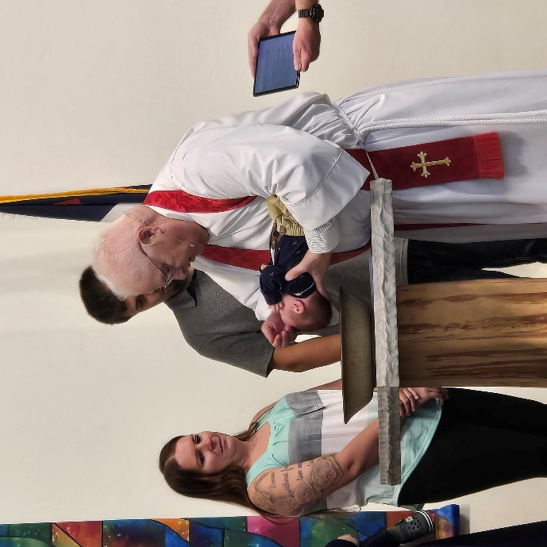
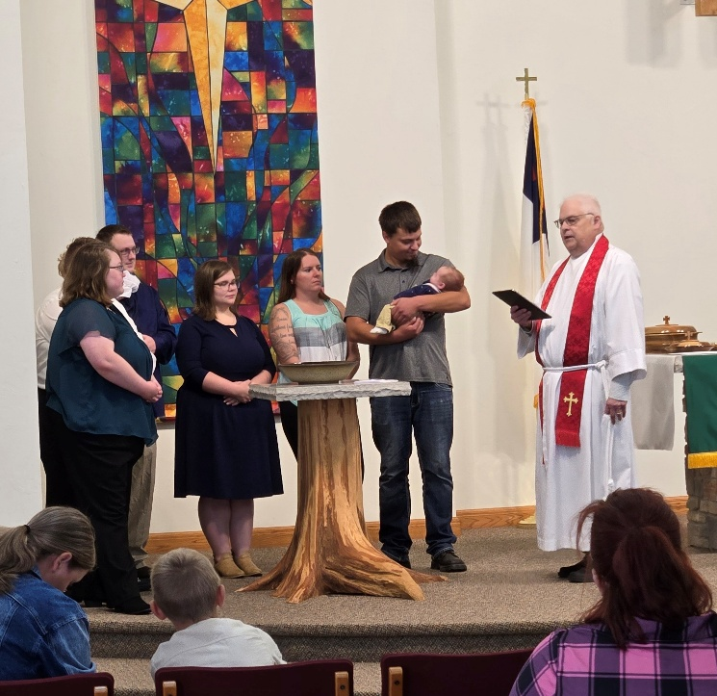
Welcome to the Family of God, Sawyer William Schaut!
Baptism

Lots of Smiles at ABC!
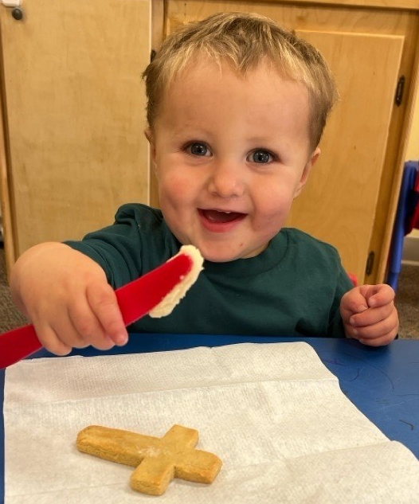
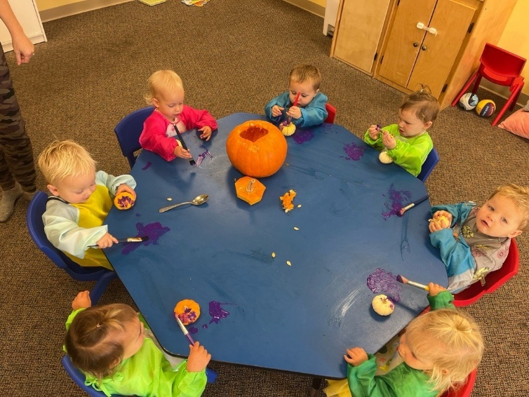

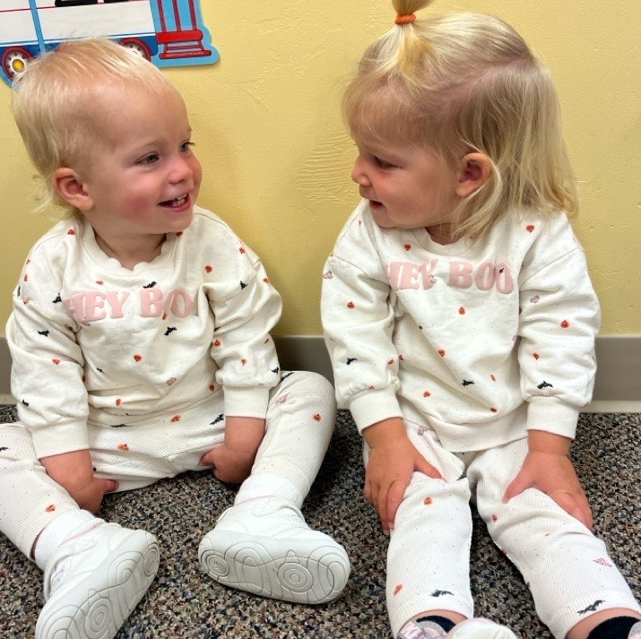


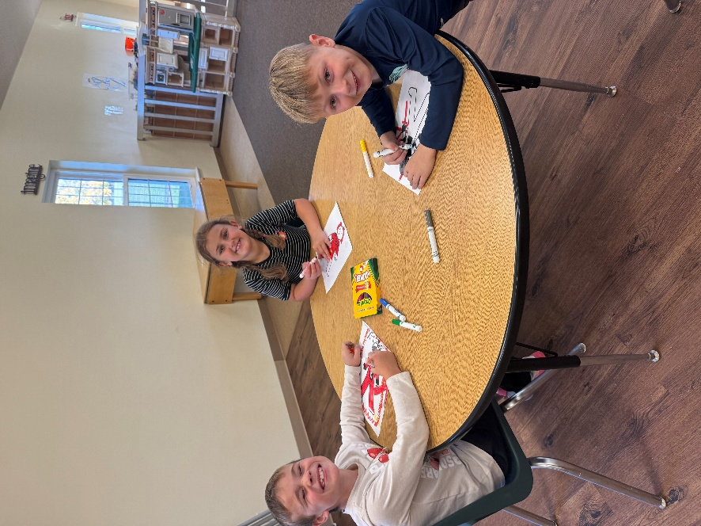

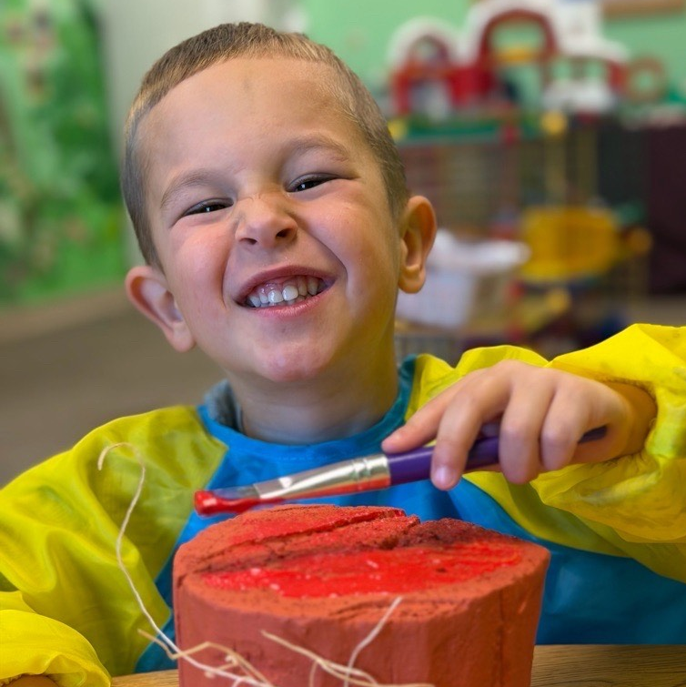

Happy Birthday!

Happy Anniversary!

Gary & Melissa Barker | 10-Nov
Wayne & Carol Schinke | 10-Nov
Paul & Teri Huempfner | 16-Nov
Reed & Pat Ott | 17-Nov

Eric Alsteen | 1-Nov
Maci Christman | 1-Nov
Nicole Franz | 3-Nov
Megan Swalheim | 5-Nov
Jude Grossheim | 6-Nov
Mary Hendricks | 7-Nov
Thatcher DeCleene | 9-Nov
Rick Schisel | 11-Nov
Bill Teske | 12-Nov
Zachary Verbeten | 12-Nov
Dave Gerrits | 14-Nov
Jack Hermann | 15-Nov
Karla Powell | 16-Nov
Kyle Swalheim | 16-Nov
Kathie Just | 25-Nov
Charlie Przybyl | 27-Nov
Ellie Przybyl | 28-Nov
Nolan Schaumberg | 29-Nov
Owen Vande Hey | 29-Nov
Brian Zuelke | 29-Nov

